Socomec places power and energy performance at the heart of rail transport

Benfeld, 02 May 2016
As a highly dynamic sector and with a drive for sustainable development, rail transport is undergoing massive changes. With its expertise and solutions, Socomec is helping rail transport professionals to meet tomorrow’s challenges: to secure rapidly increasing traffic, to modernise networks while reducing operating costs, and to optimise energy consumption.

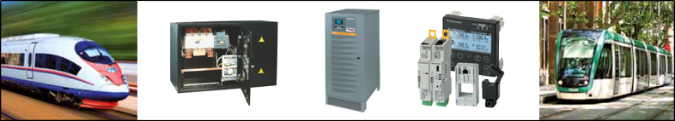

Key areas of expertise and solid references
Socomec, a family owned manufacturer for over 90 years is an industrial group with a workforce of 3,200 employees around the world. Its mission: the availability, control and safety of low voltage networks … with particular focus on the energy performance of its customers. The Socomec Group has long been involved in the rail transport sector and has produced electrical installations used on main lines, urban transport networks and in buildings both in France and internationally.

Specific solutions adapted to your requirements
With nearly 10% of sales revenue ring-fenced for R&D, Socomec places innovation at the heart of its development strategies. The Group also has an organisation dedicated to the design and production of customised solutions. This support covers all phases of rail projects, from feasibility and engineering assessment through to commissioning, including on-site training.

Low voltage solutions for railway infrastructure
Socomec’s offering meets the essential requirements of signalling systems, traction energy facilities and stations.
Our Uninterruptible Power Supplies (UPS) and AC/DC rectifiers protect and secure critical power supply systems and ensure the high availability and quality of the supply. Protection of persons and installations is assured by a wide range of switch-disconnectors, transfer switches and fuse protection equipment that has been tried and tested. In addition, innovative measurement solutions are also available for monitoring the LV network in real time.

Innovations for tomorrow’s applications
Socomec supports companies in an approach to sustainable development that aims to reduce the environmental impact of rail transport. Our solutions allow the implementation of energy efficiency policies, including critical installations and even to become a producer of renewable energy.
Our range of energy storage solutions have been stringently tested and validated for Smart Grid projects and positions Socomec as a true pioneer in this field.

Socomec will be exhibiting at InnoTrans in the French pavilion HALL 26 / 115, Berlin from 20 to 23 September 2016.

ABOUT SOCOMEC |  | MORE INFORMATION
Founded in 1922, SOCOMEC is an independent, industrial group with a workforce of 3000 people spread over 21 subsidiaries in the world. Our core business – the availability, control and safety of low voltage electrical networks with increased focus on our customers’ power performance. In 2015, SOCOMEC posted a turnover of 467 M€.  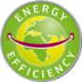 |  | Press contact:  Virginie GUYOT  Offer Communication Manager  Tel. : +33 (0)3 88 57 78 15  E-mail : virginie.presse@socomec.com  www.socomec.com

